1.
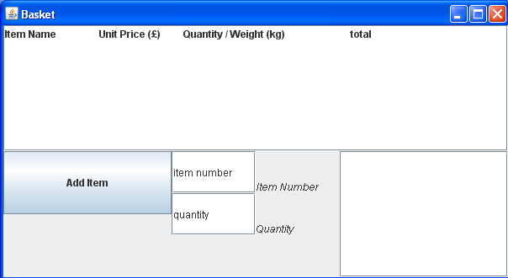

2.
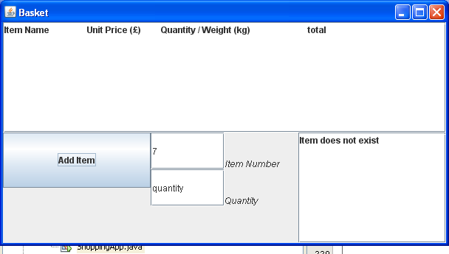

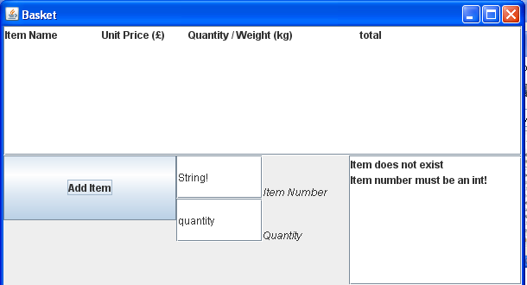

3.
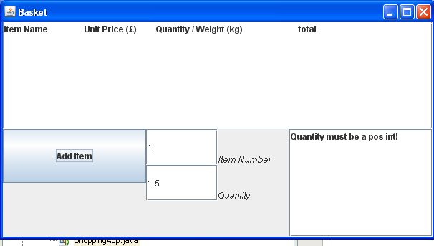

4.
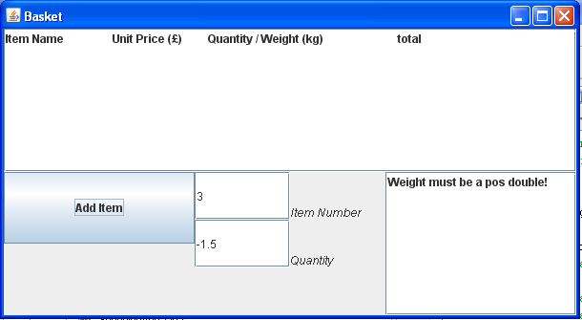

5.
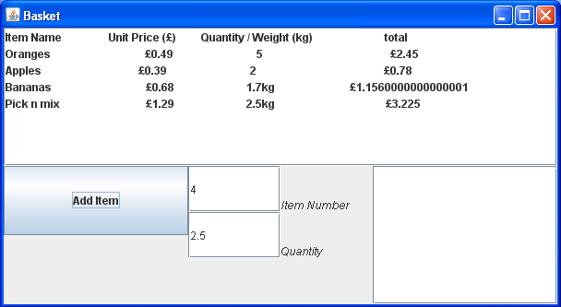

6.
public class ShoppingApp extends JFrame implements ActionListener{

static Locale currentLocale;
static ResourceBundle messages;

private JFrame mainFrame = new JFrame ("Basket");

//Panel for the buttons
private JPanel buttonPanel = new JPanel();

//Panel for the text inputs
private JPanel inputPanel = new JPanel();

//Panel to contain all of the lower part of the GUI
private JPanel lowerPanel = new JPanel();

//Scroll pane used for the shopping list
private DefaultListModel shoppingListModel = new DefaultListModel();
private JList shoppingList = new JList(shoppingListModel);
private JScrollPane listScrollPane = new JScrollPane(shoppingList);

//The two buttons for interaction
private JButton addItem = new JButton();

//The input text fields
private JTextField itemNumber = new JTextField();
private JLabel itemNumberLabel = new JLabel();
private JTextField quantity = new JTextField();
private JLabel quantityLabel = new JLabel();
private Font labelFont=new Font(itemNumberLabel.getFont().getName(),Font.ITALIC,
itemNumberLabel.getFont().getSize());

//JList to display the errors
private DefaultListModel errorListModel = new DefaultListModel();
private JList errorList = new JList(errorListModel);
private JScrollPane errorScrollPane = new JScrollPane(errorList);

private Scanner inputScanner;

private ArrayList<PurchaseByNumber> purchasesByNumber = new ArrayList<PurchaseByNumber>();
private ArrayList<PurchaseByWeight> purchasesByWeight = new ArrayList<PurchaseByWeight>();
private ArrayList<String> errorArrayList = new ArrayList<String>();

StringBuilder builder = new StringBuilder();
Formatter formatter = new Formatter(builder, Locale.US);
ItemStorage itemStorage;

/**
* @param args the command line arguments
*/
public ShoppingApp(){
itemStorage = new ItemStorage();

itemStorage.recordItem(1, "Oranges", 0.49, 0);
itemStorage.recordItem(2, "Apples", 0.39, 0);
itemStorage.recordItem(3, "Bananas", 0.68, 1);
itemStorage.recordItem(4, "Pick n mix", 1.29, 1);
itemStorage.recordItem(5, "Beef", 1.40, 1);
itemStorage.recordItem(6, "Coffee", 2.39, 0);

itemNumber.setText(messages.getString("itemNumberTextField"));
itemNumberLabel.setText(messages.getString("itemNumberLabel"));
quantity.setText(messages.getString("quantityTextField"));
quantityLabel.setText(messages.getString("quantityLabel"));
addItem.setText(messages.getString("addItem"));

addItem.addActionListener(this);

//Fix dimensions for gui
listScrollPane.setPreferredSize(new Dimension(600, 150));
buttonPanel.setPreferredSize(new Dimension(200,150));
inputPanel.setPreferredSize(new Dimension(200,150));
errorScrollPane.setPreferredSize(new Dimension(200,150));

//Setup the button panel
buttonPanel.setLayout(new GridLayout(2,2));
buttonPanel.add(addItem);

//Setup the input panel
inputPanel.setLayout(new GridLayout(3,3));
inputPanel.add(itemNumber);
inputPanel.add(itemNumberLabel);
inputPanel.add(quantity);
inputPanel.add(quantityLabel);

//Set label parameters for input panel labels
itemNumberLabel.setVerticalAlignment(SwingConstants.BOTTOM);
itemNumberLabel.setFont(labelFont);
quantityLabel.setVerticalAlignment(SwingConstants.BOTTOM);
quantityLabel.setFont(labelFont);

//Encompass all of the above in the lower panel
lowerPanel.setLayout(new BoxLayout(lowerPanel, BoxLayout.X_AXIS));
lowerPanel.add(buttonPanel);
lowerPanel.add(inputPanel);
lowerPanel.add(errorScrollPane);

//Setup the main container
Container contentPane = mainFrame.getContentPane();
contentPane.setLayout(new BoxLayout(contentPane, BoxLayout.Y_AXIS));
contentPane.add(listScrollPane);
contentPane.add(lowerPanel);

formatter.format("%1$1s %2$30s %3$30s %4$30s %n", messages.getString("itemName"), messages.getString("unitPrice"),messages.getString("quantity"),messages.getString("total"));
shoppingListModel.addElement(formatter.toString());

mainFrame.setDefaultCloseOperation(JFrame.EXIT_ON_CLOSE);
mainFrame.pack();
mainFrame.setVisible(true);

}

public void actionPerformed(ActionEvent e) {
String itemNumberText = itemNumber.getText();
String quantityText = quantity.getText();

//Exits the method if an error has been found,
//This allows all fields to be queried so all
//errors can be display, not just the one it failed
//on.
boolean errorCaught = false;

String name = "" ;
Double weight = 0.0;
int quantity = 0 ;
int itemNo = 0;
int sort = 2;

if(e.getSource()==addItem){
inputScanner = new Scanner(itemNumberText);

try{
itemNo = inputScanner.nextInt();
clearError(messages.getString("itemNoError"));
if(itemStorage.isKnownItemNumber(itemNo) == false){
displayError(messages.getString("notKnownError"));
return;
}else{
clearError(messages.getString("notKnownError"));
}
}catch(InputMismatchException ex){
displayError(messages.getString("itemNoError"));
return;
}

sort = itemStorage.getSort(itemNo);

switch(sort){
// 0 = by number purchase
case 0:
clearError(messages.getString("weightError"));
inputScanner = new Scanner(quantityText);

try{
quantity = inputScanner.nextInt();
if(quantity < 0){
displayError(messages.getString("quantError"));
errorCaught = true;
}else{
clearError(messages.getString("quantError"));
}
}catch (InputMismatchException ex){
displayError(messages.getString("quantError"));
errorCaught = true;
}
if(errorCaught)
return;
purchasesByNumber.add(new PurchaseByNumber(itemStorage.getDescription(itemNo),itemStorage.getUnitPrice(itemNo),messages,quantity));
shoppingListModel.addElement(purchasesByNumber.get(purchasesByNumber.size()-1).printPurchase());

break;
// 1 = by wieght purchase
case 1:
clearError(messages.getString("quantError"));
inputScanner = new Scanner(quantityText);
try{
weight = inputScanner.nextDouble();
if(weight < 0){
displayError(messages.getString("weightError"));
errorCaught = true;
}else{
clearError(messages.getString("weightError"));
}
}catch (InputMismatchException ex){
displayError(messages.getString("weightError"));
errorCaught = true;
}
if(errorCaught)
return;
purchasesByWeight.add(new PurchaseByWeight(itemStorage.getDescription(itemNo),itemStorage.getUnitPrice(itemNo),messages,weight));
shoppingListModel.addElement(purchasesByWeight.get(purchasesByWeight.size()-1).printPurchase());
break;
default:
break;
}

}

}

//Displays error in the error list
public void displayError(String error){
if(errorListModel.contains(error) == false){
errorListModel.addElement(error);
}
}

//Removes an error from the error list
public void clearError(String error){
for( int i = 0; i < errorListModel.size(); i++){
if(error.equalsIgnoreCase(errorListModel.get(i).toString())){
errorListModel.remove(i);
}
}
}

public static void main(String[] args) {
// TODO code application logic here
String language;
String country;

if (args.length != 2) {
language = new String("en");
country = new String("US");
} else {
language = new String(args[0]);
country = new String(args[1]);
}

currentLocale = new Locale(language, country);

try{
messages = ResourceBundle.getBundle("MessagesBundle",currentLocale);
}catch(MissingResourceException ex){
System.out.println("Cannot find resource file!!");
}

new ShoppingApp();

}

}

7.
public interface PurchaseInterface {

public String getName();
public Double getUnitPrice();
public Double getPurchasePrice();
public String printPurchase();

}

public abstract class Purchase implements PurchaseInterface {
public String name;
public Double unitPrice;
ResourceBundle messages;

public Purchase(String name, Double unitPrice,ResourceBundle messages){
this.name = name;
this.unitPrice = unitPrice;
this.messages = messages;
}

@Override
public String getName(){
return name;
}

@Override
public Double getUnitPrice(){
return unitPrice;
}

//Implemented differently in each subclass
public abstract Double getPurchasePrice();
public abstract String printPurchase();

}

public class PurchaseByNumber extends Purchase {

private int quantity;

PurchaseByNumber(String name,Double unitPrice,ResourceBundle messages,int quantity){
super(name,unitPrice,messages);
this.quantity = quantity;
}

@Override
public Double getPurchasePrice(){
assert quantity >= 0:"Quantity is invalid";
assert unitPrice >= 0: "Unit price is invalid";

return quantity*unitPrice;
}

//Additional method not in the super class
public int getQuantity(){
assert quantity >= 0:"Quantity is invalid";

return quantity;
}

@Override
public String printPurchase(){
assert quantity >= 0:"Quantity is invalid";
assert unitPrice >= 0: "Unit price is invalid";

StringBuilder builder = new StringBuilder();
Formatter formatter = new Formatter(builder, Locale.US);
formatter.format("%-30s %15s %30s %50s %n", name,"£"+ unitPrice,quantity,"£"+getPurchasePrice());

String output = builder.toString();
System.out.println(output);
return output;

}

}

public class PurchaseByWeight extends Purchase {

private Double weight;

PurchaseByWeight(String name, Double unitPrice,ResourceBundle messages, Double weight){
super(name,unitPrice,messages);
this.weight = weight;
}

@Override
public Double getPurchasePrice(){
assert weight >= 0:"Weight is invalid";
assert unitPrice >= 0: "Unit price is invalid";

return weight*unitPrice;
}

//Additional method not in the super class
public Double getWeight(){
assert weight >= 0:"Weight is invalid";

return weight;
}

@Override
public String printPurchase(){
assert weight >= 0:"Weight is invalid";
assert unitPrice >= 0: "Unit price is invalid";

StringBuilder builder = new StringBuilder();
Formatter formatter = new Formatter(builder, Locale.US);
formatter.format("%-30s %15s %30s %45s %n", name, "£"+ unitPrice,weight+"kg","£"+getPurchasePrice());

String output = builder.toString();
System.out.println(output);
return output;

}

}

8.
Erroneous inputs were handled in two stages. The first stage was making sure that the input was in the correct format. This was checked by catching any exceptions. The second was checking that the numeric values were valid, ie, greater than or equal to zero.
The errors were displayed in a JList on a scroll pane. The contents of the JList were determined by a list model. This was basically treated like an array list. The method addError(String) checked the contents of the list model for the error to be added, if it wasn’t already on the list it would be added. The method clearError(String) looked through the list model using a for loop for the error to be cleared, if it found it the error would be removed from the list model and hence the Jlist.

9.
I created a class “ItemStorage” that basically handled the data structure. Item storage has a Hash Map “itemMap” that stores the different items that can be purchased The reason I chose a hash map as my data structure is because the data we wish to store is inherently keyed. The Item number is a unique key and so this can be used directly as the key for the hash map.
As the data needed about the items isn't just a single variable I also created the class “Item” that contains all the item data. This is then stored in the hash map against the relevant key / item number.

10.
Most of this assignment was a success. The data structure worked well and the overall program functioned correctly. The only thing I wasn't sure about was whether it would be good practice to include the assertion messages in the resource bundle so that they too could be internationalised. I found that passing the resource bundle through was rather cumbersome, perhaps there is another way to do this.

